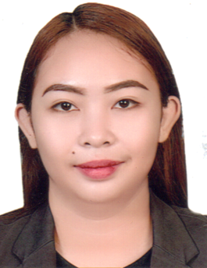**JERIECILLE MARIE S. PALBAN**

PUROK 4 BLISS SAN MIGUEL, TAGUM CITY  
DAVAO DEL NORTE 8100  
Mobile: +639530445647

### Email: [jeriecillemar08@gmail.com](mailto:jeriecillemar08@gmail.com) CAREER OBJECTIVES Dedicated and compassionate babysitter with nearly three years of experience providing exceptional care to children of various ages. Skilled in creating a safe, engaging, and nurturing environment that supports children's physical, emotional, and developmental growth. Committed to fostering trust with families and ensuring the well-being and happiness of children under my care.

### PERSONAL DATA Age 26 Gender: Female Date of Birth January 8, 1998 Place of Birth Tagum City Civil Status Married Citizenship Filipino Religion Catholic Height 5’2 ft. Weight 56.5 kg Language Vernacular, English, Filipino EDUCATIONAL BACKGROUND Secondary : Alternative Learning System (ALS) Inclusive Year of attendance: 2015-2016 Tagum City National Comprehensive High School Inclusive Year of attendance: 2009-2013 Primary : Magugpo Pilot Central Elementary School Inclusive Year of attendance: 2003-2009 **EXPERIENCE**

* Babysitter ( 3 years)

Mendoza Family

Tagum City, Davao del Norte, Philippines

2015-2018

* Taking care of my own Child

2018-present

Provided full-time care for children from newborn to 8 years old.

Ensured safety and well-being by supervising playtime, meals, and nap schedules.

Organized educational and recreational activities to promote learning and creativity.

Assisted with homework and school projects to support academic progress.

Maintained cleanliness of play areas and handled light housekeeping related to childcare.

Established positive relationships with children and their families by fostering open communication.

Responded calmly and effectively to emergencies and minor illnesses, ensuring proper first-aid response when needed.

**Skills**

Strong understanding of child development and age-appropriate care

Excellent communication and problem-solving abilities

Patient, compassionate, and adaptable

Proficient in time management and multitasking

Basic first-aid and CPR knowledge.

**EXAMS/TRAININGS/CERTIFICATE**• TESDA NC2 Caregiving  
  
I hereby certify that the information written is true and correct.  
  
  
 **JERIECILLE MARIE S. PALBAN  
 Applicant**